GESU LIBRARY BIRTHDAY BOOK PROGRAM
“A good book is a good friend”

Dear Parents,
Consider sharing your child’s birthday with the school community by donating a book to the Gesu Library in their honor. Participation in the program involves a $16 donation per book. Each child participating will select a new book from the Birthday Book Shelf in the library. We will put a special bookplate in the book and the birthday child has the honor of being the first to check out the book. If you would like to participate in the Gesu Library Birthday Book Program, fill out the form below and return it anytime this school year until May 1 with your donation in an envelope marked Library Birthday Book. By joining now, rather than waiting for your child’s birthday, these special books can be enjoyed by many students for the entire school year.
The children have a special appreciation for the books they have selected to add to our library shelves. They enjoy sharing them with their classmates. These books will remain special throughout all their years at Gesu. This is a wonderful way to commemorate a very special occasion and to help our library maintain a high-quality collection.
Your generosity will benefit all our students. We thank you for your participation and support.

Sincerely,

Paula Rownd, Librarian

Please cut on line and return lower portion only with your check.

YES, I want my child to be part of the Birthday Book Program!

NAME ____________________________

Birthday (month/date)

GRADE HOMEROOM
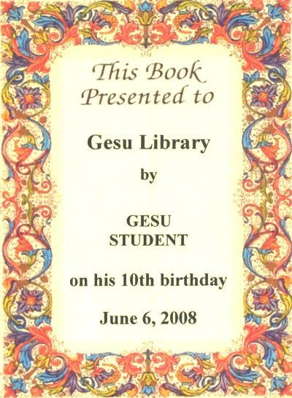
Other special occasion/ in honor of_____________________________________________

Enclose $16 per book. Checks should be made payable to Gesu School Library. You may write one check per family, but please complete a separate tear slip for each child.

