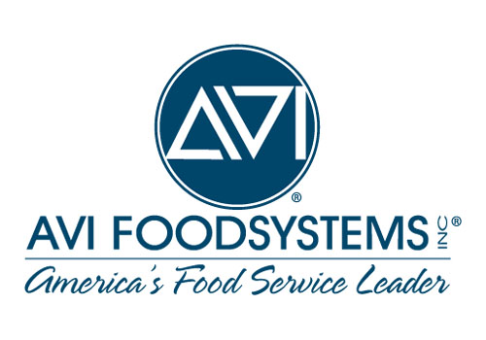

Gesu Catholic School
Lunch Program
Prices (effective August 2019)

Student Lunch | $3.75
Adult/Guest Lunch | $4.25
Main Entrée/Pizza | $2.50
Chips/Pringles | $1.25
Gatorade (Large) | $2.00
Gatorade (Small) | $1.25
Snapple | $1.50
Juicy Juice | $1.25
Yogurt/Pudding Parfait | $2.50
Fresh Fruit Cup | $1.50
Large Muffin | $1.25
Small Salad | $2.50

